***Overview:***

The flight reservation application described in this documentation is named Union Flight, and allows users (customers) to reserve flights online and purchase tickets. A detailed description of the application was provided in phase 2 of the project. In this documentation we provide the core technologies used to develop this application along with instructions on how to operate.

|  |  |
| --- | --- |
| ***Core technologies*** | ***Description*** |
| Apache httpd 2.2 | Server |
| PHP 5.2 | Processes server-side scripts and generates html |
| MySQL 5.5 | DBMS for interacting with database |

***Operation instructions***

Structure of the application.

The flight reservation application is a website that consists of a root directory called Website. Inside the Website directory are four subdirectories (CSS, Resources, Scripting, and Web Pages). Below is a description of each subdirectory.

* The CSS directory:

The CSS directory contains one file named ‘page_style_1.css’ (without quotes) which contains all the formatting information of the site’s pages.

* The Resources directory:

The Resources nests another directory named *Images,* which stores all the resources (images) used as the application’s pages background.

* The Scripting directory:

The Scripting directory stores all the scripts (PHP files) that execute on the server. Some of these files are used to interact with the database and render the result of that interaction as html that is displayed on the browser. Others however are used for database-specific operations.

* The Web Pages directory:

The Web Pages directory solely consists of .html files that a customer can browse through when utilizing the application.

Operation mode:

The flight reservation application is primarily database-driven. Consequently, some access needs to be granted to interact with the back-end database. In this application we have set up a password to connect to the MySQL DBMS. For fun, we’ve chosen the password to be “Metalgearsolid3” (without quotes), a fabulous tactical espionage action game. The username is ‘root’ (without quotes), the default username. The connection to the DBMS using the password can be found in the following files:

* Website\Scripting\create_new_customer.php, on line 50.
* Website\Scripting\Customers_List.php, on line 6.
* Website\Scripting\Delete_Script.php, on line 11.
* Website\Scripting\Flight_Reservation_Database.php, on line 9
* Website\Scripting\Search_Script.php on line 34.
* Website\Scripting\Update_Script.php, on line 58.

That being said, here is how to proceed to successfully run the application:

Once all the technologies (Apache, PHP, and MySQL) are installed in the system,

* Place the Website folder in the root directory.
* Locate and load the Flight_Reservation_Database file(Website\Scripting\Flight_Reservation_Database.php) in the browser (just enter the url in the address bar as <http://localhost/Website/Scripting/Flight_Reservation_Database.php> , where localhost is the name of the root directory). This will create tables in the database and populate some of them.
* Locate and load the ‘airlines.create.php’ file in the same directory. This will populate the AIRLINES table in the database. This is our list of airlines.
* Finally, locate and load the ‘flights_create.php’ file in the same directory. This will populate the Flights table in the database. This is our default list of flights.
* Once done, you can open the Website\index.php file in the browser, as your point entry to the application. This will allow you to set up a new customer account, and upon success, a new entry will be added in the database, and you will be redirected to the customer page from where you will be able to navigate through all the application’s pages.

***The User Interface:***

* The customer registration page:

The customer registration page allows new customers to set up an account.

Upon successful registration an entry is created in the database for the customer.

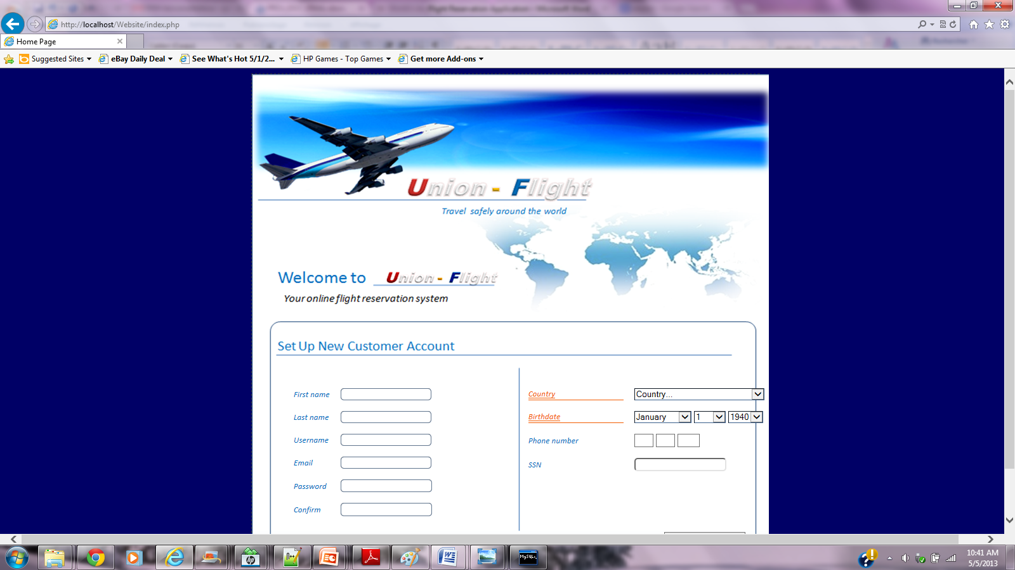

Customer registration interface

***The Customer’s home page***

Upon successful registration of the customer, they are redirected to the home page where they can reserve a flight and choose many other options.

Customer’s home page

